Level 3 Food Science and Nutrition Transition Work-
Moving from Year 11 Curriculum to the Level 3 Course
Task 1: Food Diary Detective
Keep a 3-day food diary (including one weekend day).

For each day:
- Record everything you eat and drink.
- Estimate portion sizes where possible.
- Reflect on:
  - Which foods provide carbohydrates, protein, and fats?
  - Are you eating at least five portions of fruit and vegetables?
  - What changes could improve the nutritional balance of your diet?

Task 2: Food in the News
Find a recent news article about food, nutrition, sustainability, food technology, or health.
Create a short summary that includes:

- The title of the article
- A 100-word summary
- Why it interests you
- One question you would like to investigate further

Task 3: Nutrition Challenge
Choose one of the following groups:
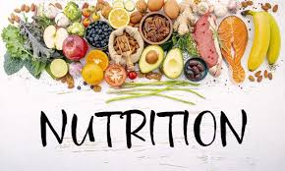
- Teenagers
- Athletes
- Older adults
- Vegetarians/Vegans
Research:
- Their nutritional requirements
- Nutrients that may be lacking in their diet
- Examples of suitable foods
Present your findings as an infographic, poster, or one-page fact sheet.

Task 6: The Future of Food
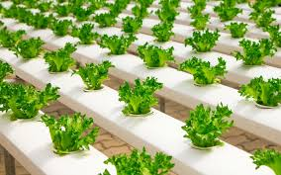
Imagine it is the year 2050.
Write a short paragraph or create a mind map answering:
- What foods might people be eating?
- How might technology change food production?
- What challenges will the food industry face?
Be creative but support your ideas with research where possible.

Extension Challenge – explore the following Ted Talks-

How the food you eat affects your brain - Mia Nacamulli
How the food you eat affects your gut - Shilpa Ravella
Are food preservatives bad for you? - Eleanor Nelsen
The science of spiciness - Rose Eveleth

