ST BERNARD’S HIGH SCHOOL
GCSE → A-LEVEL PHYSICS
TRANSITION WORKBOOK
AQA A-level Physics (7408)
Summer transition booklet for students starting Year 12

Name: ____________________________ Form: ____________________________

Purpose of this booklet
This workbook is designed to bridge GCSE Physics to AQA A-level Physics. It focuses on the mathematical fluency, conceptual depth and practical thinking needed for a strong start in Year 12.
- How to use it:
- Complete the baseline tasks without notes first.
- Use the reading boxes to fill gaps in understanding.
- Show full working in calculations and keep units throughout.
- Attempt the challenge questions if you finish early.
- Use the reflection boxes to identify topics to revise before September.

Contents
- 1. Baseline diagnostic quiz
- 2. Core maths for A-level Physics
- 3. Measurements, units and uncertainty
- 4. Motion, forces and graphs
- 5. Waves
- 6. Electricity
- 7. Mechanics and materials bridge
- 8. Stretch reading: particles and radiation
- 9. Practical skills bridge
- 10. End-of-workbook mixed review
- 11. Teacher answer key

1. Baseline diagnostic quiz
Reading: Complete this section without notes. It is designed to show which GCSE ideas need revisiting before September.
Questions
- 1. Convert 0.0035 A into mA.
- 2. A car travels 180 m in 12 s. Calculate its average speed.
- 3. State the difference between mass and weight.
- 4. A wave has frequency 50 Hz and wavelength 0.68 m. Calculate its speed.
- 5. A 12 V battery drives a current of 0.40 A. Calculate the power transferred.
- 6. Sketch a velocity–time graph for an object accelerating uniformly from rest.
- 7. Explain why current is the same at every point in a series circuit.
- 8. A spring extends by 4.0 cm when a force of 2.0 N is applied. Calculate the spring constant.
- 9. Give one example of a scalar quantity and one example of a vector quantity.
- 10. State one source of uncertainty when timing a moving object with a handheld stopwatch.
Challenge / extension
- Write one paragraph explaining how this topic becomes more mathematical at A-level than at GCSE.
Teacher notes / concise answers
- 1) 3.5 mA
- 2) 15 m s^-1
- 3) mass = amount of matter / inertia; weight = gravitational force
- 4) 34 m s^-1
- 5) 4.8 W
- 8) 50 N m^-1

2. Core maths for A-level Physics
Reading: A-level Physics rewards students who are comfortable rearranging equations, using powers of ten, interpreting graphs and spotting proportional relationships.
Reading: At GCSE, many questions tell you exactly which equation to use. At A-level, you are more often expected to choose an appropriate model, combine ideas and explain why a particular equation applies.
Questions
- a) Rearrange v = u + at to make t the subject.
- b) Rearrange ρ = m/V to make V the subject.
- c) Write 0.000072 in standard form.
- d) Convert 3.6 × 10^6 J into MJ.
- e) Evaluate (2.4 × 10^-3) × (5.0 × 10^2).
- f) A graph has gradient 3.5 × 10^-2. Write this as an ordinary decimal.
- g) State whether the following are directly proportional, inversely proportional or neither: current and p.d. for a fixed resistor; pressure and area for a fixed force; GPE and height for fixed mass.
Challenge / extension
- A quantity varies with t². Sketch what a graph of the quantity against t would look like, and what a graph against t² would look like.
Teacher notes / concise answers
- a) t = (v-u)/a
- b) V = m/ρ
- c) 7.2 × 10^-5
- d) 3.6 MJ
- e) 1.2
- f) 0.035

3. Measurements, units and uncertainty
Reading: AQA begins with measurements and their errors because every practical and many exam questions depend on careful handling of units and uncertainty.
Reading: Students must use SI base units confidently, convert between prefixes and comment on uncertainty, precision, accuracy and percentage uncertainty.
Questions
- 1. A ruler reads to the nearest millimetre. What is the absolute uncertainty in a single length measurement?
- 2. A student measures a wire diameter as 0.46 mm with a micrometer. Explain why a micrometer is better than a ruler for this measurement.
- 3. A pendulum time for 10 oscillations is 14.8 s ± 0.2 s. Calculate the percentage uncertainty in the time for one oscillation.
- 4. Why is timing 20 oscillations usually better than timing just 1 oscillation?
Challenge / extension
- Write one paragraph explaining how this topic becomes more mathematical at A-level than at GCSE.
Teacher notes / concise answers
- 1) ±0.5 mm
- 3) percentage uncertainty = (0.2 / 14.8) × 100 ≈ 1.35%

4. Motion, forces and graphs
Reading: Mechanics is one of the most important transition areas because GCSE ideas about speed, acceleration and force become more mathematical and more graphical at A-level.
Reading: At A-level you need to move flexibly between words, equations and graphs. The gradient of a velocity–time graph gives acceleration. The area under a velocity–time graph gives displacement.
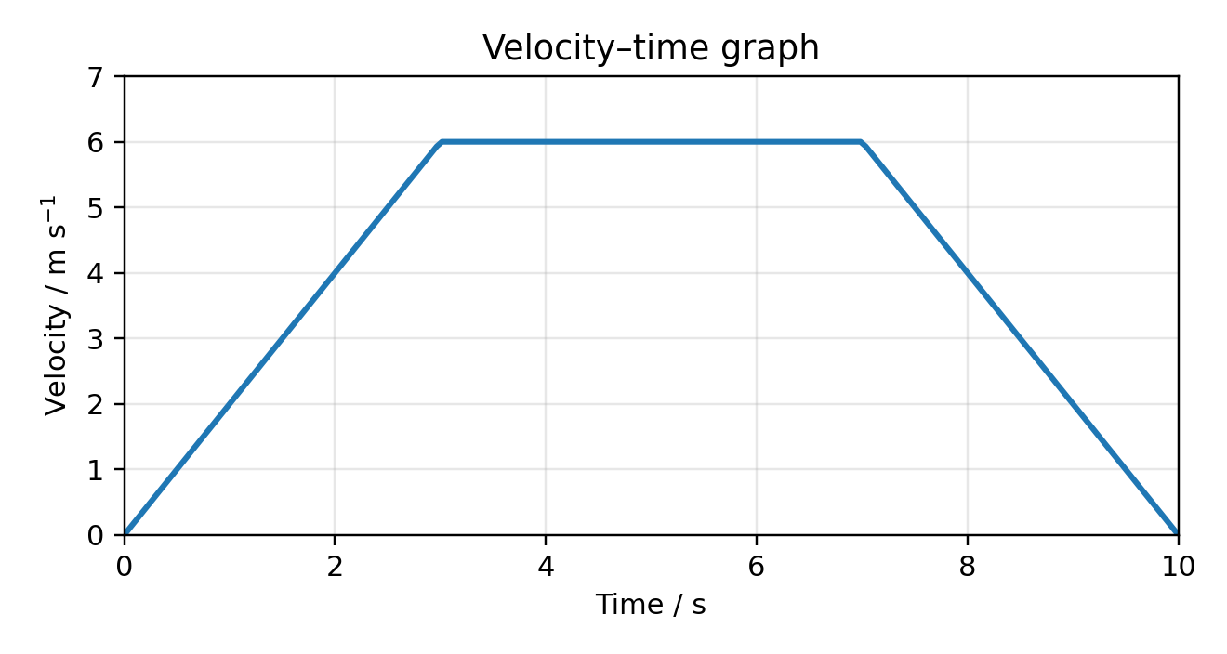
Questions
- 1. Using the velocity–time graph, describe what happens to the object’s motion in each time interval.
- 2. Estimate the acceleration in the first 3 s.
- 3. Calculate the displacement during the constant-speed section.
- 4. Explain how you would find the total distance travelled from the graph.
- 5. A 12 N force acts horizontally and an 8 N force acts vertically. Calculate the resultant force.
- 6. A 5.0 kg object accelerates at 2.4 m s^-2. Calculate the resultant force.
- 7. A ball of mass 0.20 kg changes velocity from 4.0 m s^-1 east to 3.0 m s^-1 west. Calculate the change in momentum.
Challenge / extension
- A force acts at 35° above the horizontal. Resolve a 20 N force into horizontal and vertical components.
Teacher notes / concise answers
- 2) acceleration ≈ 2.0 m s^-2
- 3) displacement during constant-speed section = area = 6 × 4 = 24 m
- 5) resultant = √(12² + 8²) ≈ 14.4 N
- 6) F = ma = 12 N
- 7) initial p = +0.8 kg m s^-1 east; final p = -0.6 kg m s^-1; change = -1.4 kg m s^-1

5. Waves
Reading: AQA A-level waves include phase difference, stationary waves, diffraction, refraction, interference and the particle nature of light.
Reading: GCSE wave speed is still essential, but you also need to explain wave behaviour using superposition and phase.
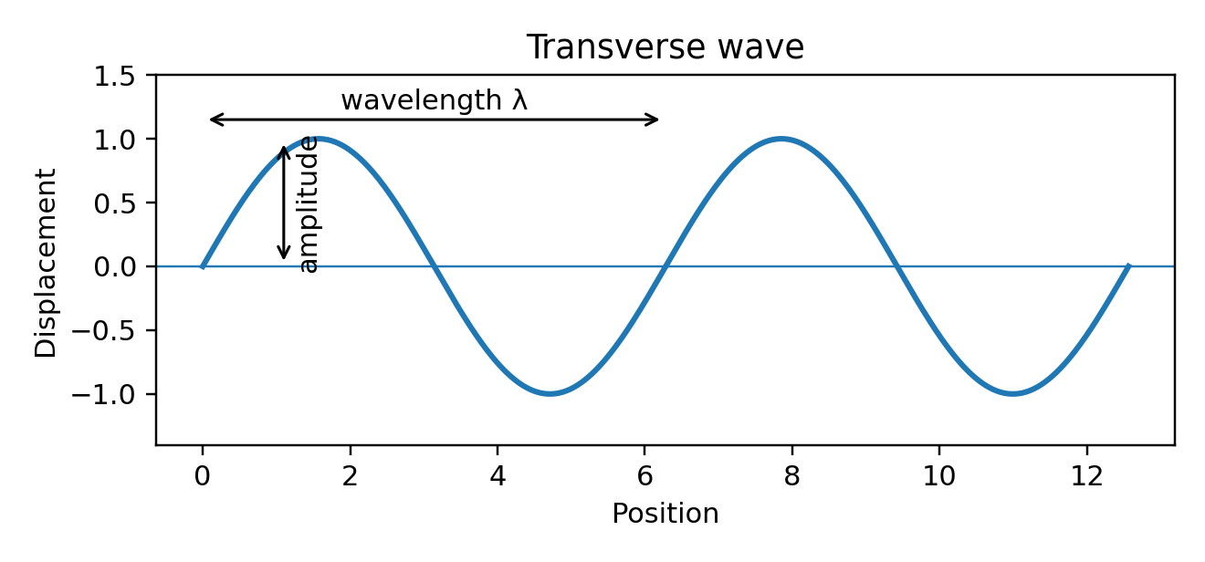
Questions
- 1. Label amplitude and wavelength on the wave diagram.
- 2. A wave has frequency 120 Hz and speed 48 m s^-1. Calculate its wavelength.
- 3. State the phase difference between two points one full wavelength apart.
- 4. Explain why diffraction is more noticeable when the gap size is similar to the wavelength.
- 5. Describe one difference between a stationary wave and a travelling wave.
Challenge / extension
- Research the difference between coherent and incoherent sources, and explain why lasers are useful in interference experiments.
Teacher notes / concise answers
- 2) wavelength = 0.40 m
- 3) 360° or 2π rad

6. Electricity
Reading: A-level electricity builds on current, potential difference and resistance by introducing resistivity, internal resistance, potential dividers, emf and terminal p.d.
Reading: Students must explain current in terms of charge flow and often combine circuit ideas with graph interpretation.
Questions
- 1. Define current in terms of charge and time.
- 2. A charge of 360 C passes a point in 3.0 minutes. Calculate the current.
- 3. A resistor has a resistance of 24 Ω and the current through it is 0.50 A. Calculate the potential difference.
- 4. Explain why the resistance of a metal wire usually increases as temperature rises.
- 5. A 9.0 V battery with internal resistance supplies a current of 0.30 A. Explain why the terminal potential difference is less than 9.0 V.
Challenge / extension
- Sketch an I–V graph for a filament lamp and explain why it is not a straight line.
Teacher notes / concise answers
- 1) current is charge flow per unit time
- 2) 2.0 A
- 3) 12 V

7. Mechanics and materials bridge
Reading: This section links GCSE forces to A-level materials, one of the topics students often find unfamiliar.
Reading: Hooke’s law states that, up to the limit of proportionality, extension is proportional to force. At A-level you move beyond springs to stress, strain and Young modulus.
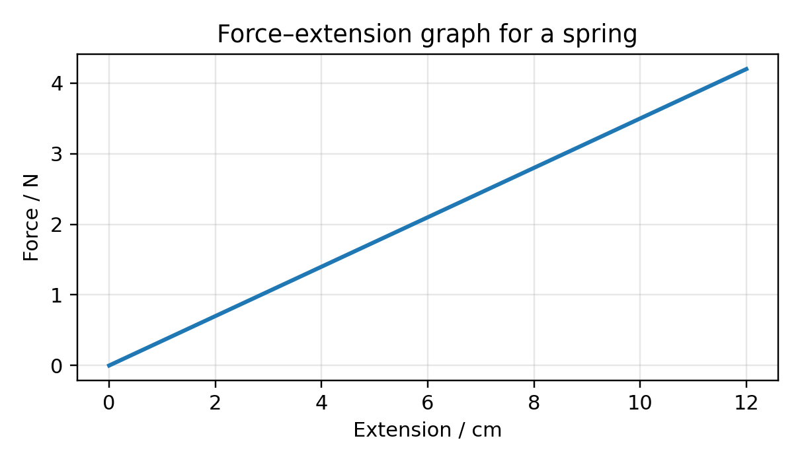
Questions
- 1. A spring of spring constant 35 N m^-1 extends by 0.080 m. Calculate the force.
- 2. State the difference between elastic deformation and plastic deformation.
- 3. A wire of original length 2.0 m extends by 1.5 mm. Calculate the strain.
- 4. A force of 120 N acts on a wire with cross-sectional area 2.5 × 10^-6 m^2. Calculate the stress.
- 5. Explain what the gradient of a force–extension graph represents for a spring.
Challenge / extension
- Research what Young modulus tells us about a material and give one example of where this matters in engineering.
Teacher notes / concise answers
- 1) 2.8 N
- 3) strain = 7.5 × 10^-4
- 4) stress = 4.8 × 10^7 Pa

8. Stretch reading: particles and radiation
Reading: Particles and radiation is often the first topic that feels completely new compared with GCSE.
Reading: AQA expects students to know that the Standard Model contains quarks, leptons and force carriers. They also need to understand photons as quanta of electromagnetic radiation with energy E = hf.
Questions
- 1. Research the difference between a proton and a positron.
- 2. Explain what is meant by antimatter.
- 3. Find out what the unit electronvolt (eV) measures and convert 1 eV into joules.
- 4. Write a short paragraph on why physicists use models such as the Standard Model.
Challenge / extension
- Write one paragraph explaining how this topic becomes more mathematical at A-level than at GCSE.

9. Practical skills bridge
Reading: Practical work matters in AQA A-level Physics because practical skills are assessed both in written papers and through the practical endorsement.
Reading: Strong practical physicists record raw data clearly with units, think about uncertainty before starting, repeat measurements and comment on anomalies.
Questions
- 1. Design a method to determine the spring constant of a spring.
- 2. Suggest variables to control when investigating the resistance of a wire.
- 3. Explain why a fiducial marker can improve the accuracy of a timing practical.
- 4. A student obtains one point far from the line of best fit. List three sensible things they should check before discarding it.
Challenge / extension
- Write one paragraph explaining how this topic becomes more mathematical at A-level than at GCSE.

10. End-of-workbook mixed review
Reading: Use this as a final check of your readiness for A-level. Show full working and identify any topics that still feel shaky.
Questions
- 1. A cyclist accelerates from 3.0 m s^-1 to 9.0 m s^-1 in 4.0 s. Calculate the acceleration.
- 2. A 0.75 kg object is raised through 2.4 m. Calculate the gain in gravitational potential energy.
- 3. A wave has wavelength 0.25 m and frequency 1400 Hz. Calculate its speed.
- 4. A current of 2.0 A flows for 5.0 minutes. Calculate the charge transferred.
- 5. A metal wire has resistance 8.0 Ω and potential difference 12 V across it. Calculate the current.
- 6. A spring stores 1.2 J of elastic energy when extended by 0.15 m. Use E = 1/2 kx^2 to find the spring constant.
- 7. A 1500 kg car travelling at 18 m s^-1 brakes to rest. Calculate its initial momentum.
- 8. State two ways to reduce percentage uncertainty in a timing experiment.
- 9. Explain the difference between precision and accuracy.
- 10. Write a short reflection: Which three topics do you most need to revise before starting A-level Physics?
Challenge / extension
- Write one paragraph explaining how this topic becomes more mathematical at A-level than at GCSE.
Teacher notes / concise answers
- 1) 1.5 m s^-2
- 2) 17.6 J
- 3) 350 m s^-1
- 4) 600 C
- 5) 1.5 A
- 6) ≈107 N m^-1
- 7) 2.7 × 10^4 kg m s^-1

11. Teacher answer key
1. Baseline diagnostic quiz
- 1) 3.5 mA
- 2) 15 m s^-1
- 3) mass = amount of matter / inertia; weight = gravitational force
- 4) 34 m s^-1
- 5) 4.8 W
- 8) 50 N m^-1
2. Core maths for A-level Physics
- a) t = (v-u)/a
- b) V = m/ρ
- c) 7.2 × 10^-5
- d) 3.6 MJ
- e) 1.2
- f) 0.035
3. Measurements, units and uncertainty
- 1) ±0.5 mm
- 3) percentage uncertainty = (0.2 / 14.8) × 100 ≈ 1.35%
4. Motion, forces and graphs
- 2) acceleration ≈ 2.0 m s^-2
- 3) displacement during constant-speed section = area = 6 × 4 = 24 m
- 5) resultant = √(12² + 8²) ≈ 14.4 N
- 6) F = ma = 12 N
- 7) initial p = +0.8 kg m s^-1 east; final p = -0.6 kg m s^-1; change = -1.4 kg m s^-1
5. Waves
- 2) wavelength = 0.40 m
- 3) 360° or 2π rad
6. Electricity
- 1) current is charge flow per unit time
- 2) 2.0 A
- 3) 12 V
7. Mechanics and materials bridge
- 1) 2.8 N
- 3) strain = 7.5 × 10^-4
- 4) stress = 4.8 × 10^7 Pa
10. End-of-workbook mixed review
- 1) 1.5 m s^-2
- 2) 17.6 J
- 3) 350 m s^-1
- 4) 600 C
- 5) 1.5 A
- 6) ≈107 N m^-1
- 7) 2.7 × 10^4 kg m s^-1

Maths Skills Introduction
This workbook revises the GCSE mathematics needed for A-level Physics. Each section contains notes, worked examples and practice questions. Show all working and use SI units throughout.
1. Unit Conversions
Worked Examples
1. 3.6 kHz = 3600 Hz
2. 25 cm = 0.25 m
3. 8 ms = 0.008 s
Practice Questions
1. Convert 4.2 kHz to Hz.
2. Convert 650 mm to m.
3. Convert 7.5 μs to s.
4. Convert 0.85 kg to g.
5. Convert 420 cm to m.
6. Convert 6.2×10⁻³ m to mm.
7. Convert 2.4 MHz to Hz.
8. Convert 95 g to kg.
9. Convert 3.8 km to m.
10. Convert 12 ns to s.
2. Area and Volume
Notes
· Area measures surface covered. Volume measures space occupied.
· Triangle = ½bh, Rectangle = lw, Circle = πr², Cuboid = lwh, Cylinder = πr²h
Worked Examples
4. Triangle b=8,h=5 ⇒ 20 cm²
5. Cuboid 4×5×8=160 cm³
6. Cylinder r=3,h=10 ⇒ 283 cm³
Practice Questions
1. Area of triangle b=12,h=9.
2. Area of rectangle 8×15.
3. Area of circle r=7.
4. Volume of cube side 6.
5. Volume of cuboid 4×7×10.
6. Volume of cylinder r=5,h=12.
7. Volume of sphere r=4.
8. Volume of cone r=6,h=9.
9. Volume of triangular prism area=20,length=8.
10. Mixed geometry problem of your choice.
3. Pythagoras
Notes
· For right-angled triangles only: a²+b²=c².
Worked Examples
7. 3,4 ⇒ c=5
8. c=13,a=5 ⇒ b=12
9. Rectangle 9×12 diagonal=15
Practice Questions
1. Find hypotenuse: 5 &12.
2. Find hypotenuse:8 &15.
3. Missing side c=25,a=7.
4. Missing side c=17,a=8.
5. Ladder problem.
6. Field diagonal.
7. TV diagonal.
8. Drone displacement.
9. Cuboid space diagonal.
10. Extension challenge.
4. Trigonometry
Notes
· SOH: sin=Opp/Hyp
· CAH: cos=Adj/Hyp
· TOA: tan=Opp/Adj
· Use inverse trig to find angles. Ensure calculator is in degrees.
Worked Examples
10. Opp=6 Adj=8 ⇒ θ=36.9°
11. Hyp=15 θ=35° ⇒ Opp=8.6 cm
12. Adj=10 θ=42° ⇒ Hyp=13.5 cm
Practice Questions
1. Find θ: Opp=7 Adj=9.
2. Find θ: Opp=8 Hyp=12.
3. Find θ: Adj=12 Hyp=20.
4. Find opposite.
5. Find adjacent.
6. Find hypotenuse.
7. Ramp angle.
8. Kite height.
9. Ladder height.
10. Aircraft climb.
5. Direct and Inverse Proportion
Notes
· Direct: y=kx. Inverse: y=k/x. Also know y∝x² and y∝1/x².
Worked Examples
13. Extension-force example
14. Journey time-speed example
15. y∝x² example
Practice Questions
1. 10 proportional reasoning questions (direct, inverse, square and inverse square).
6. Rearranging Formulae
Notes
· Undo operations in reverse order. Remove fractions first. Square both sides when needed.
Worked Examples
16. v=u+at ⇒ t=(v-u)/a
17. E=½mv² ⇒ v=√(2E/m)
18. f=(1/2L)√(T/μ) ⇒ T=4μL²f²
Practice Questions
1. Rearrange v=u+at for t.
2. Rearrange F=ma for m.
3. Rearrange V=IR for R.
4. Rearrange P=W/t for W.
5. Rearrange E=½mv² for m.
6. Rearrange R=ρL/A for A.
7. Rearrange f=1/T for T.

